***Task 1***

**Compose a code in Assembly language to left shift (one time) a 16-bit number of your choice by**

**using only “SHL”. Apply the concept of extended shifting as well on the same number and**

**compare the results of both shifting methods.**

**Show the number you are shifting in 16-bit binary, hexadecimal and decimal format before and**

**after shifting it once. (Hint: You may use the calculator of Windows in its programmer mode**

**and show all these values in a screenshot or notepad++ can also be used for this purpose**

**(notepad++ →plugins → converter → conversion panel).**

***Through Normal Shifting***

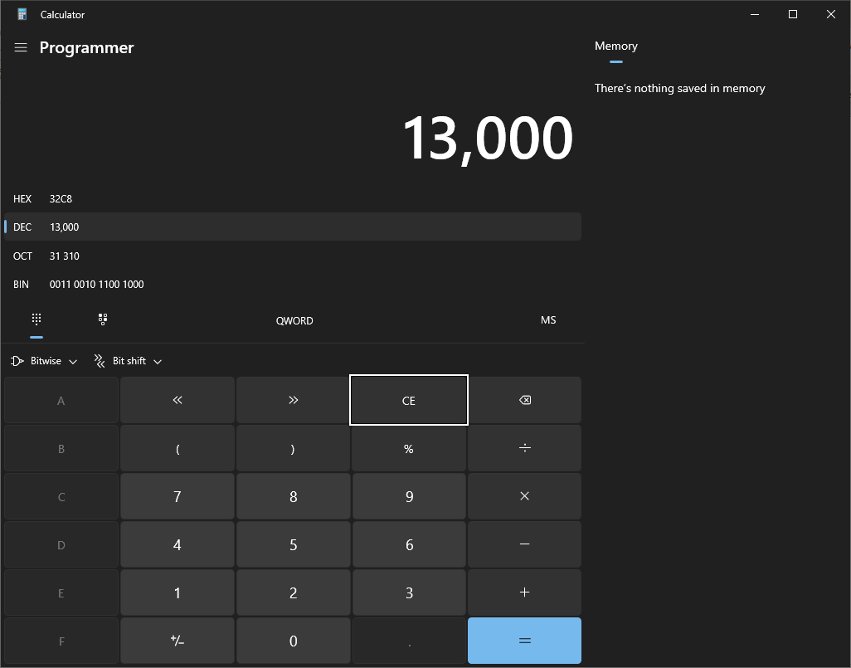

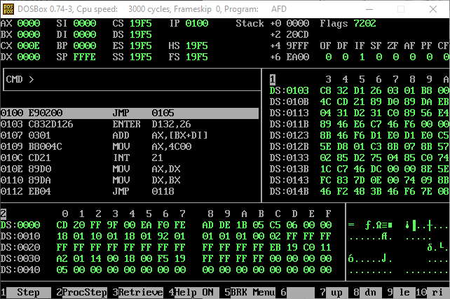

***After Shifting***

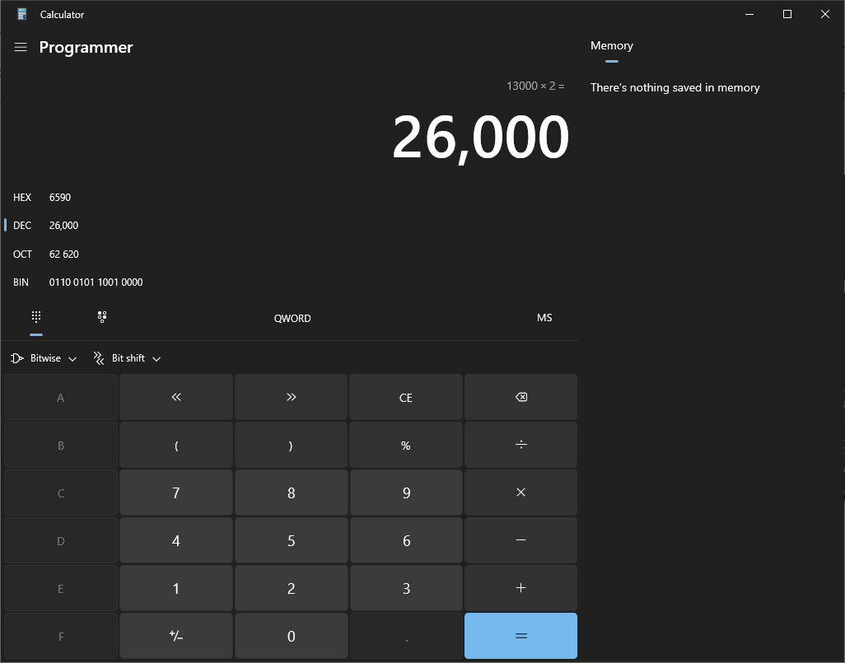

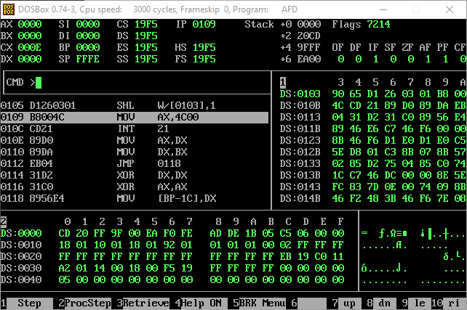

***Through Extended Shifting***

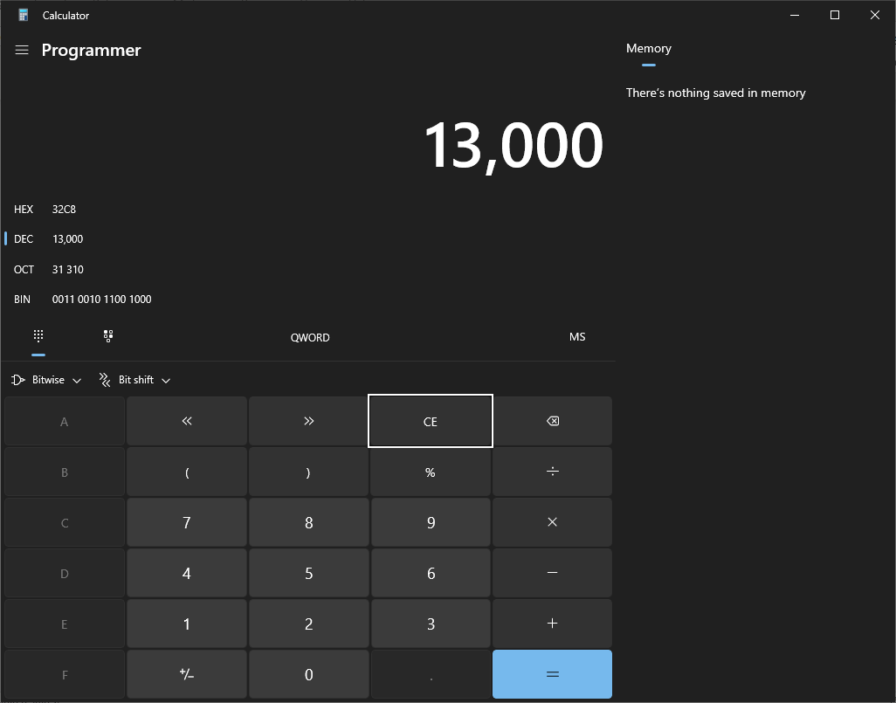

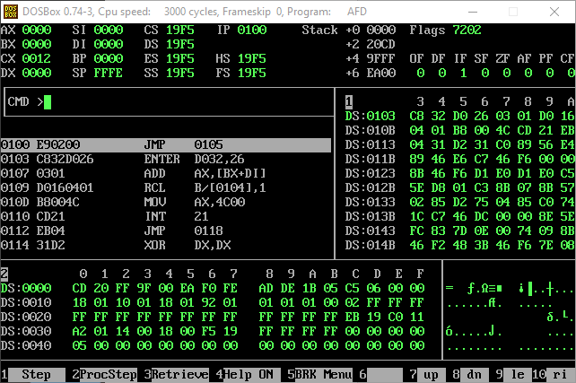

***After Shifting***

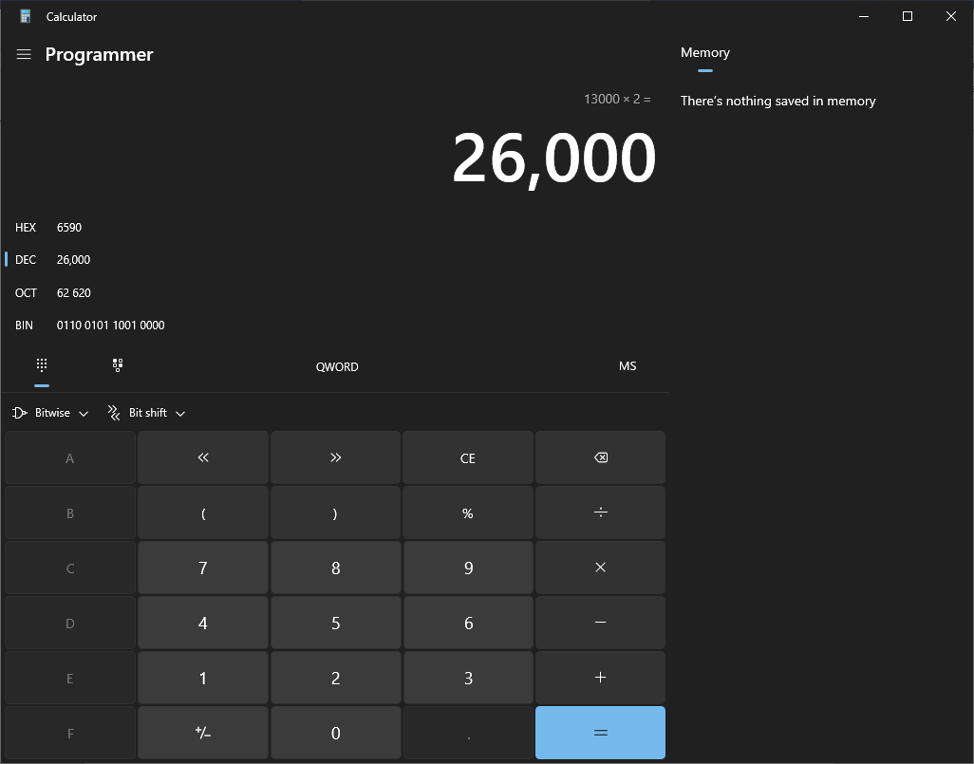

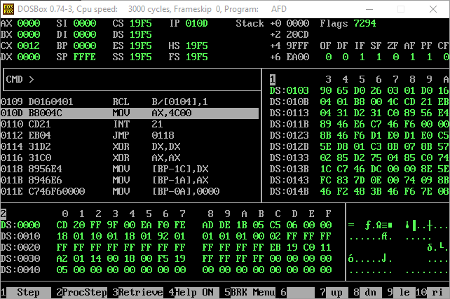

***By Comparing the Results Both Are Same.***

***Task 2***

**Write a code in Assembly language to add two 16-bit numbers of your own choice by applying**

**the concept of extended addition. Show the numbers you are adding in 16-bit binary,**

**hexadecimal and decimal format before addition. Do the same once you have added the numbers**

**and show the result as said above.**

***First Num***

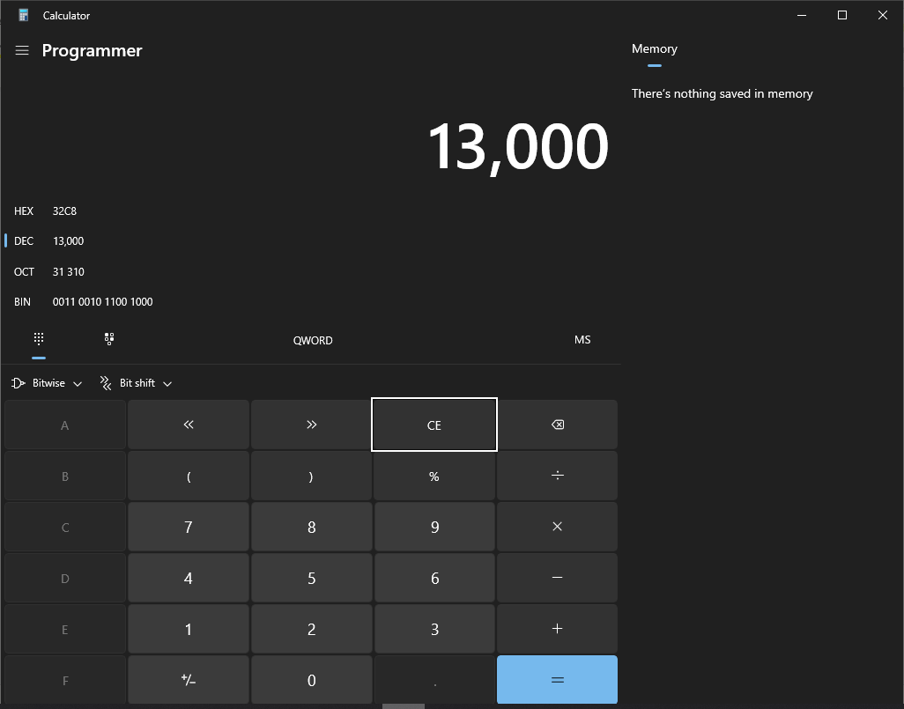

***Second Number***

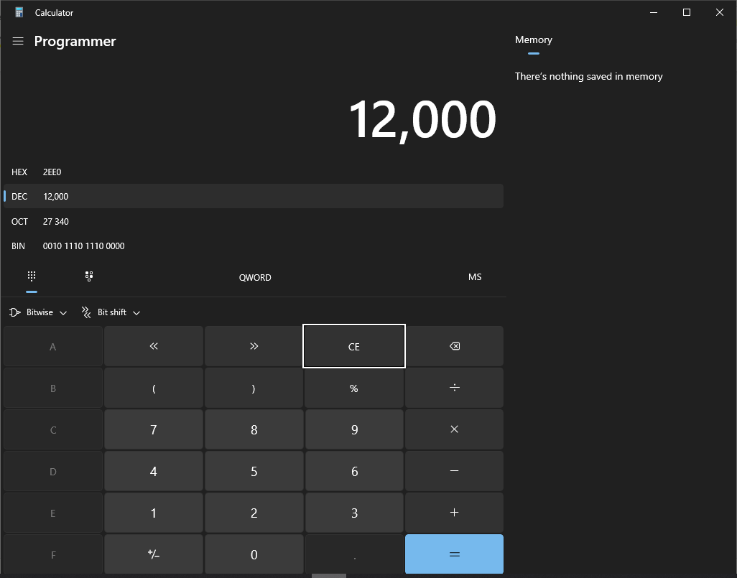

***Addition***

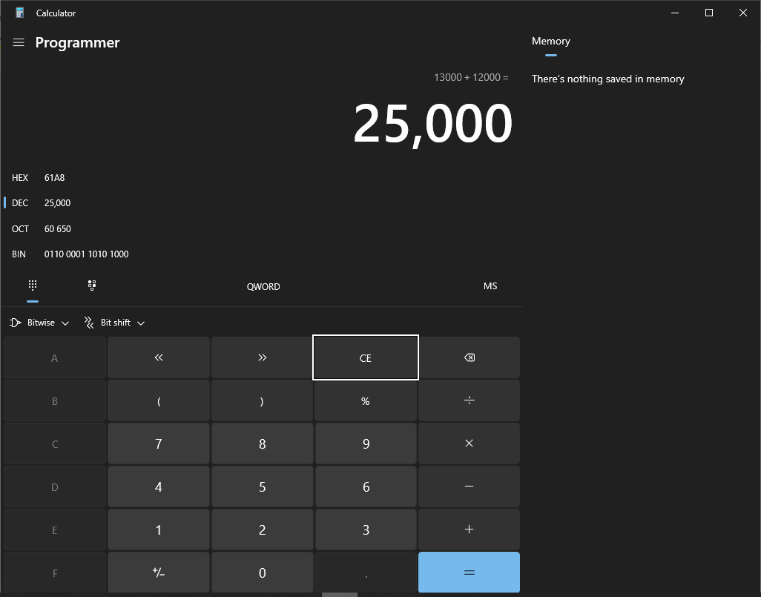

***Now through AFD Showing***

***Before Addition: -***

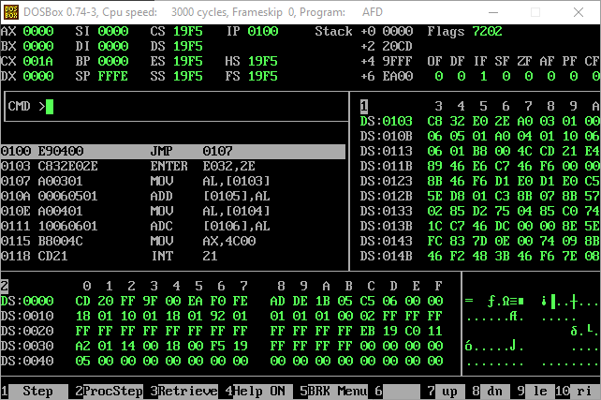

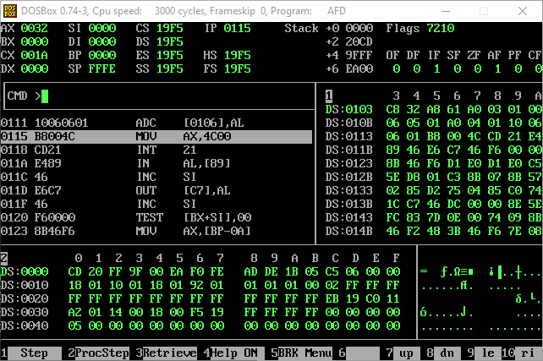***After Addition: -***

***Task 3***

**Apply the concept of extended shifting and addition for the multiplication of two 8-bit numbers**

**of your own choice.**

***Multiplicand: -***



***Multiplier: -***

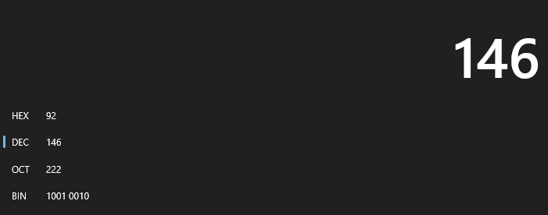

***Result: -***

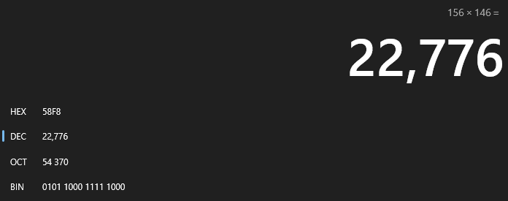

***Initial Values By Looking In AFD : -***

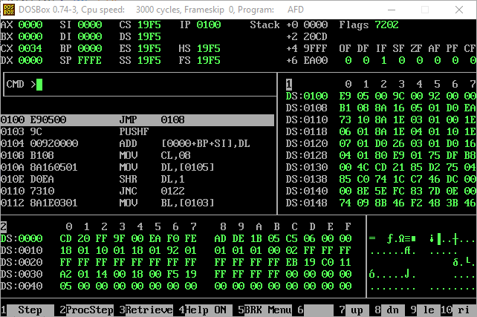

***Result: -***

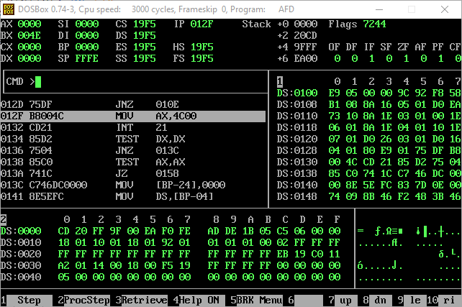

***Task 4***

**Repeat task 3 for two 16-bit numbers of your own choice.**

***Multiplicand: -***



***Multiplier: -***



***Result: -***

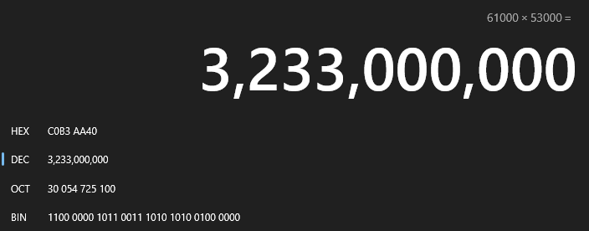

***Initial Values By Looking At The AFD: -***

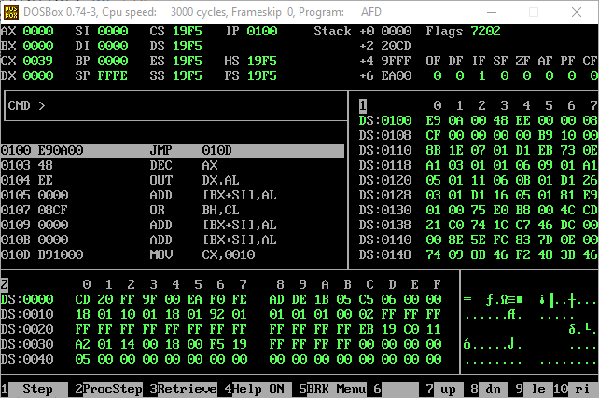

***Result: -***

